**Head Shaping in the Open Crib**

Infant on square pillow with head in midline

Use large tube WITH straps to keep head in midline

Use small tube WITHOUT straps at feet of baby

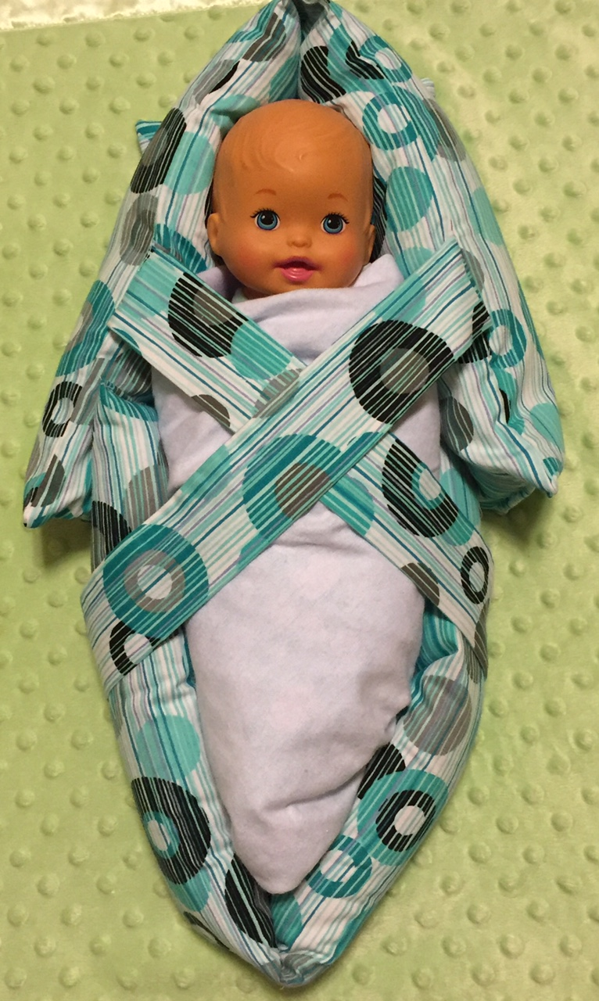

www.shaperight.net